MySql Assignment

**Table of Contents**

Accessing MySql

Available databases

Available tables

Table View

## Introduction

I was tasked with setting up a MySql database that had five tables and different columns inside them. After that I had to create queries for the tables.

## Accessing MySql

Access the MySQl server: 127.0.0.1/phpmyadmin ( to access you must be the root user or administrator and there is no password for the database because it is hosted locally.)

## Available databases

* Umuzi: Under Umuzi there are two databases. The first named umuzi has my first iteration of my database. A few errors were made in it so I created a new database called umuzi_final which is clean and free of errors.

## Available tables

The Umuzi database contains five tables, these tables are:

* Customers
* Employees
* Orders
* Payments
* Products

The tables and columns in my Umuzi database are shown below with more information about them like their primary keys.

## Table View

### Customers

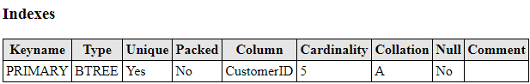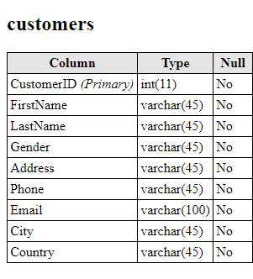

### Employees

### 

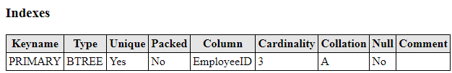

### Orders

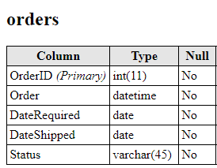

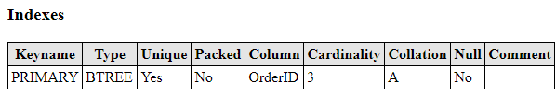

### Payments

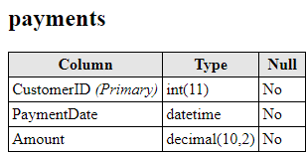

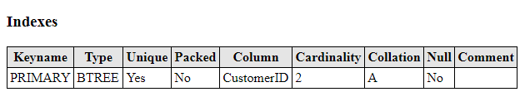

### Products

